Expt No:  06 | SEQUENTIAL OPERATION OF A STEPPER MOTOR
Date:
/ /2025

- AIM:

To design a ladder logic program to perform the sequential operation of a stepper motor using PLC.

- APPARATUS REQUIRED:

- Stepper Motor.
- PLC Trainer Kit.
- Personal Computer [PC].
- VersaPro Software Installed.
- RS - 232 cable.
- Patch Chords.

- PROCEDURE:

- Load the Versapro Software to the PC.
- Open the Versapro Software.
- Switch ON the PLC Trainer and stepper motor.
- Connect PLC and stepper motor.
- Open the New folder and draw the ladder logic program.
- Connect the PLC to PC.
- Select the correct hardware Configuration [Sl. No].
- Store the Program to PLC.
- Run the Program.
- Verify the performance of the stepper motor.

- PROBLEM STATEMENT:

Develop a ladder logic program to drive a 4-phase stepper motor. The program must generate a continuous "wave drive" (one-phase-on) excitation by energizing the four motor coils (Q1, Q2, Q3, Q4) in a repeating sequential pattern:
- Coil 1 ON, Coils 2,3,4 OFF
- Coil 2 ON, Coils 1,3,4 OFF
- Coil 3 ON, Coils 1,2,4 OFF
- Coil 4 ON, Coils 1,2,3 OFF
This sequence must loop to produce continuous rotation. The speed of rotation must be governed by an adjustable timer that controls the time delay, or "step," between each phase change. The system shall be controlled by a Start and Stop input.

- WIRING DIAGRAM:

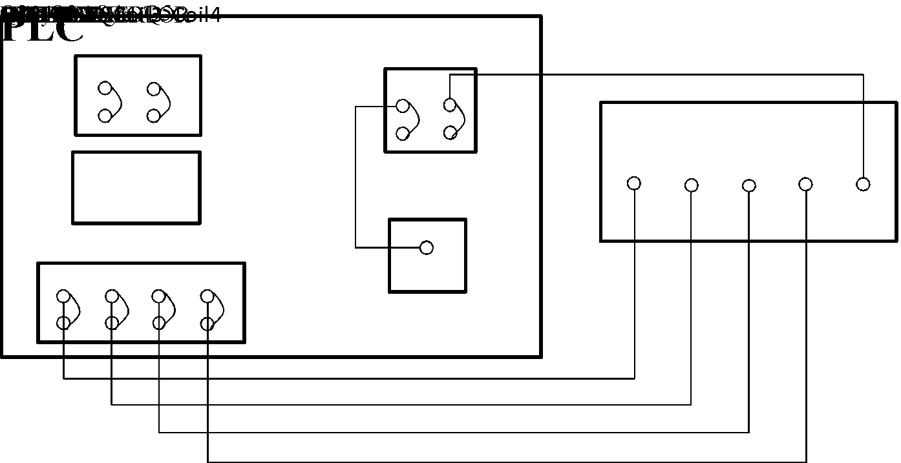

- LADDER DIAGRAM:

- I/O MAPPING:

- RESULT:
Thus, Ladder logic program for sequential operation of stepper motor has been designed and the performance is tested using trainer kit.

